**Test environment:** <http://18.212.158.87:8080/ticketadvantage/login.html>

**Production environment:** <http://18.209.12.116:8080/ticketadvantage/login.html>

**Updates for TA from Olga**

1. Create a PENDING PAGE-Once you click on PENDING Icon it should take you to a page which has all of our plays in the transaction format that have not concluded Pending Bets are bets that have not yet been played or are currently being played. Once the game is over, the play should be in graded and in FIGURES, Removed from the Pending Page.

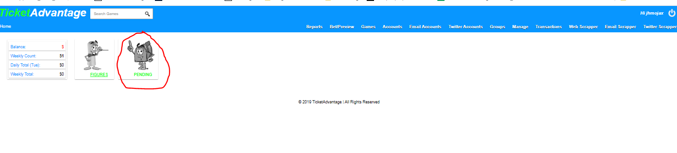

1. New Column Headers for Transactions to Exported-New columns are highlighted in Yellow



A-Game Date

B-Rotation

C- Description

D-Account Name

E-Picked Up from Source

time TA picked up the play from the source

F- Destination Accepted Date/Time

G- Execution Time

How long did it take between E & F?

H-Type

I-Risk

J-Win

K-Owner % Risk

L-Owner % Win

M-Line

N-Juice

O-Owner %

P-Partner %

Q-Ticket #

R-Outcome

S- Owner % Outcome

T- Source Name

U-Closing Line

V-Closing Juice

W-Delta

X-Bookmaker

Y-Destination Software Type

Z-Source Software Type

AA-Closing Line Book

3) 2h plays should record the closing line. They can come from the source pictured below:

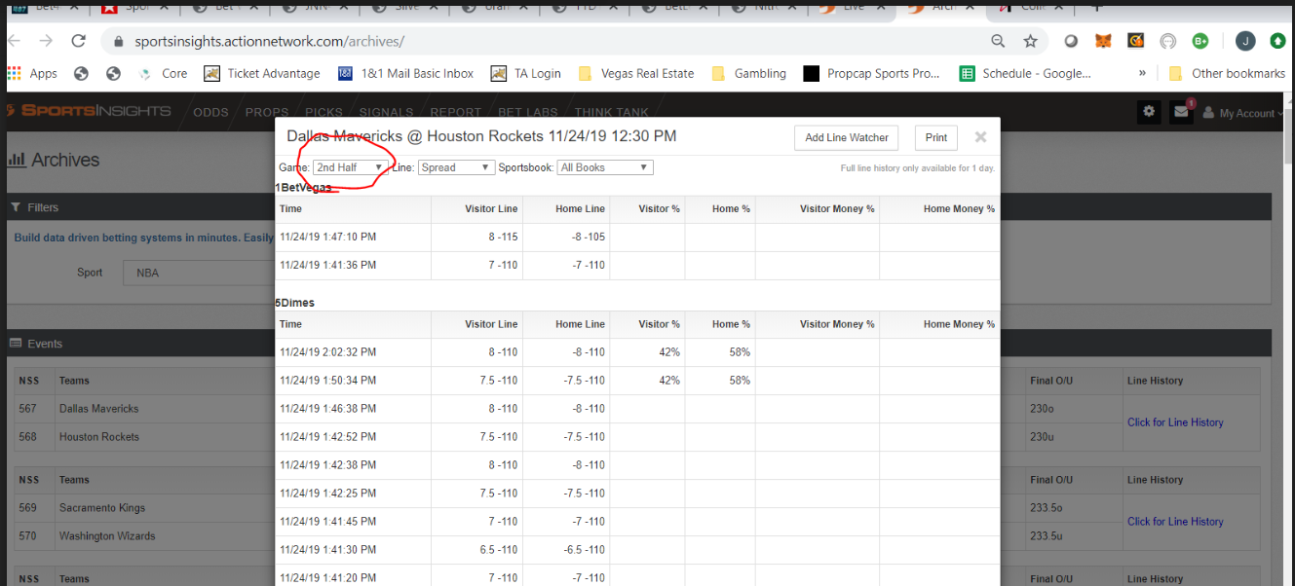

4.) Add border to excel report

5.) Set Today as default in transaction pag